

Allen Valley Velo presents

**The M24.8 CTT open time trial.**

**Sunday 17th July 2022.**

Promoted for and on behalf of Cycling Time Trials under its rules & regulations.

This is a Northumberland & Durham Cycling Association Event.

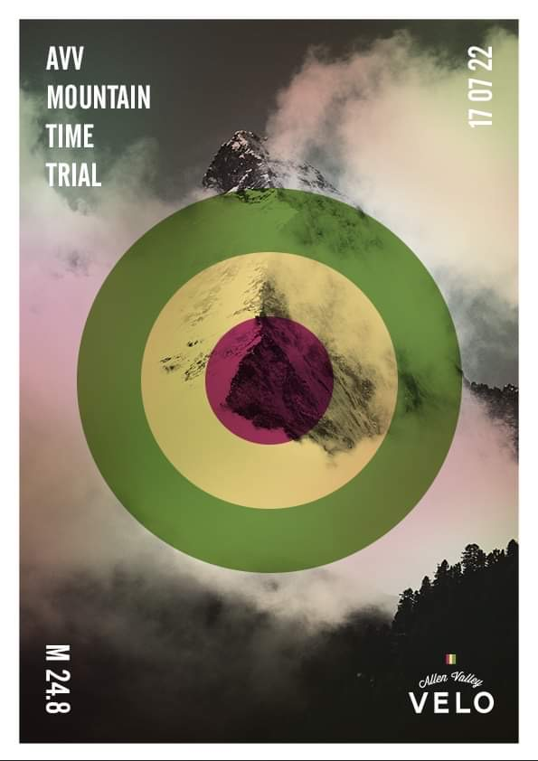

**First Rider: 10:00**

Timekeepers: Frances Schultz, Peter Schultz & Sharon Dyson  
Event Secretary: Howard Buckingham, [howiebuckingham@hotmail.co.uk](mailto:howiebuckingham@hotmail.co.uk), 07946 593 141

Results will be posted on the Northumberland & Durham Cycling Association Facebook page as soon as they are received from the Timekeepers on the afternoon of the event.

**Event Sign on and Parking:**

**Allendale Primary School Sports Hall,**

**Allendale Town.**

**Northumberland.**

**NE47 9PS.**

**COVID19– PLEASE READ CAREFULLY**

* Competitors should not attend if they feel ill in ANY way or if family members have any symptoms.
* Event sign on will be located outside Allendale Primary School Sports Hall.
* Please use the hand sanitiser provided before and after signing on/off.
* Rider number will be pre cleaned with disinfectant and spread out or hung up to avoid handling.
* An elevated resting heart rate or exceptionally quick to react heart rate during warm- up can suggest an underlying asymptomatic illness of ANY kind. You should NOT start the event (DNS) and leave immediately. Do not go to the start line if you feel this is the case and notify the organiser of your intention not to start as a result of an adverse warm-up.
* Please report to the start line no more than 5 minutes before your designated start time.
* Riders will have the choice of self-start, with one foot on the ground or being held up. NO track stands
* DRAFTING – SOCIAL DISTANCING: If you catch up with another rider during your race, try to pass as quickly as possible and under no circumstances ride close behind so as to take shelter from the wind.

**PARKING, SIGN ON AND START LOCATION**

There is ample parking at the Sports Hall car park, on the road outside and in the town square, but please park considerately and with sufficient space. Sign on will be available from 9:00am. Allendale Primary School Sports Hall is approximately 1 mile from the start. Please ensure that numbers are returned after the event and remember to sign off; otherwise your time won’t be recorded in the official results.

The start is at 5 Lane Ends (Thornleygate), about 1 mile from the school. Turn left out of the school, go through the Village Square, Turn right down the steep Peth Hill and follow the road up a hill to the Thornleygate junction.

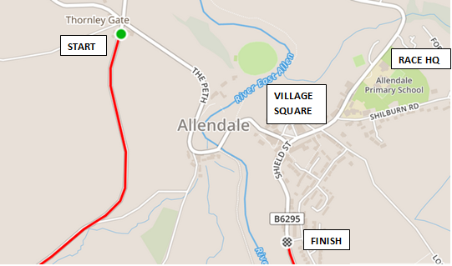

**COURSE**

This is the fifth year of using the M24.8 course, which is a scenic single hilly loop of approximately 25miles starting and finishing on the outskirts of Allendale Town. With over 2600ft of climbing this is a challenging course.

**CTT COURSE DESCRIPTION:**

*START at drain cover alongside field gate on minor road 100 metres south of the T-junction with the B6295 at Thornley Gate. Proceed south on the minor road through Carrshield to the T-junction with the A689 near Nenthead. Turn left on to the A689 and continue south east to the T-junction with the B6295 at Cowshill. Turn left on to the B6295 and proceed north through Allenheads to FINISH at the south boundary sign of Allendale Town.*

Route: <https://www.strava.com/routes/4690835>

**COURSE SAFETY NOTES**

**0-1 Miles** – The opening section is in a very poor condition and requires attention. A safe line can be found but eyes must be kept on the road in front. We have been applying pressure on NCC to improve the road for the last 3 months to no avail. Red flags will be located here.

**5.5 Miles** – Fast descent with a cattle grid at 5.5miles. Take care.

**9 Miles** – Turn 1 is approached downhill and is a 90 degree. left turn. Please take care and slowdown in time. There will be a marshal with a red flag 100m before the turn warning you to adjust speed.

**9.5 Miles** – Steep and fast descent from the top of Killhope Cross into Weardale. Take care control your speed and keep the brakes covered!

**14 Miles** – Turn 2 is a very sharp tight left turn up a sharp rise, so when approaching this preselect an easier gear to be able to make the turn. The marshal on this corner will be watching to make sure the white line is not crossed as you make the turn (warning – crossing the line is not only dangerous but risks disqualification)

**17 Miles** – You will pass through Allenheads Village at speed so please take care.

**24 Miles** – The final approach into Allendale, passes under trees, which shade the road. Take care as the road surface here is in poor condition.

**After the finish line- Please slow down immediately as you enter the village as there will be a community music event taking part in the town square and there are likely to be families of pedestrians crossing the road.**

**Pay attention to the on the day risk assessment, located at sign on as this may detail additional hazards.**

**RIDER INSTRUCTION**

* Your machine must have working front and rear lights (flashing or constant) to be permitted to race (No light no ride!).
* No U turns to be made by riders in the vicinity of the timekeeper at the start.
* Riders take extra care at junctions, turns, blind summits, on steep descents with bends, and through built-up areas.
* Riders must stay on the correct side of the road at all times.
* Head down riding is strictly forbidden.
* No dismounting by riders in finishing area.
* Riders should note that large parts of the course are minor rural roads.
* Please shout your number as you pass the finishing timekeeper.
* If you forget to sign out, you will be recorded as a “DNF” on the results sheet.
* Junior riders should bring a completed Parental Consent form in order to be allowed to ride. To assist the Timekeepers at the finish line can you please ensure that your number is correctly placed and visible from the rear in line with CTT regulations.
* If your number is too high, the Timekeepers may not be able to see it. The number shall be centrally positioned below the waist so as to be clearly visible from the rear when the rider is in his/her normal riding position.

**In the interests of your own safety, Cycling Time Trials and the event promoters require you to wear a HARD SHELL HELMET that meets an internationally accepted safety standard.**

**This rule now applies to All competitors.**

This event may be subject to a Doping Control. Race numbers required for Doping Control will be displayed at sign out. If your number is displayed you should report immediately to Doping Control which will be nearby. Remember, it is up to you to check and ensure that you comply. If required you must report to Doping Control after finishing without delay.

**ROAD BIKE CATEGORY**

If you are entering the road bike category the N&DCA road bike rules apply, which prohibit the use of tri bars, TT helmets and wheels deeper than 60mm. For the definitive rules for this please refer to the N&DCA Rules pages 4 and 5: <https://drive.google.com/file/d/0Bw21vA7dHXgkdUJlanVWVEViSEE/view>

When signing on please indicate your entry into the road bike category by adding an (R) after your name.

**PRIZES (all given out after the event)**

**Due to us having to exit the HQ Hall by 1pm, prizes/ tea will be likely to be given out outside (providing we have good weather).**

* Fastest Male rider on the day will be awarded the Dave McManus trophy to keep till the next year.
* Fastest Female rider on the day will be awarded the club trophy made by John Forster to keep till next year .

|  |  |  |  |
| --- | --- | --- | --- |
|  | MALE | FEMALE | TOTAL |
| 1st Overall | £20.00 | £20.00 | £40.00 |
| 2nd Overall | £15.00 | £15.00 | £30.00 |
| 3rd Overall | £10.00 | £10.00 | £20.00 |
| Road Bike | £10.00 | £10.00 | £20.00 |
| Junior/Juvenile** | £10.00 | £10.00 | £20.00 |
| Vet 40 | £10.00 | £10.00 | £20.00 |
| Vet 50 | £10.00 | £10.00 | £20.00 |
| Vet 60+ | £10.00 | £10.00 | £20.00 |

** Junior/Juvenile is a combined prize category.

One rider, one prize.  In the event of a rider winning two prizes, the highest prize amount will be awarded, and the second prize awarded to the next rider in that category.

At the prize giving Tea, Coffee and a small selection of cakes / biscuits will be served. Catering equipment, disposable cups, plates and tableware has kindly been provided by Sue Bell, owner of:



Violet’s Quality Tableware Hire,

Unit 7, The Lime Works,

Fourstones,

Hexham,

Northumberland,

NE47 5DQ.

<Tel:07735462671>.

E mail: [Sue.vtableware@gmail.com](mailto:Sue.vtableware@gmail.com)

Website: [www.violetstableware.com](http://www.violetstableware.com)